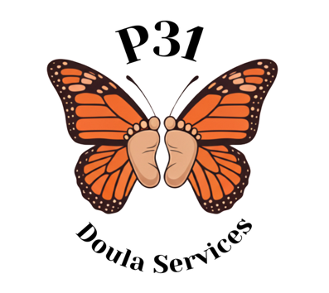
Resource List
The Baby Pantry - Greater DC Diaper Bank | Food pantry that provides food, formula, breastfeeding supplies, bottles, pacifiers, adult hygiene items, baby hygiene items, adult diapers, menstrual hygiene products, potty-training supplies, and more to families in need.
Breastfeeding Center for Greater Washington | Breastfeeding/Lactation information and classes
Support for First Time Moms - Nurse Family Partnership | first time mom wanting a personal nurse as guidance
Pages - Medicaid Centering Pregnancy Services (maryland.gov) (for Medicaid patients) | Pregnancy support group
Children & Families | 211 Maryland (211md.org) | Support for Children and Families
Lactation Classes | UM Capital Region Health (umms.org) | Free Lactation classes/Breastfeeding classes for moms
Classes and Events | UM Charles Regional Medical Center (umms.org) | Childbirth classes
Home - House of Ruth Maryland (hruth.org) | Domestic Violence assistance
Domestic Violence | Prince George's County (princegeorgescountymd.gov) | Domestic Violence resources
Psychology Today: Health, Help, Happiness + Find a therapist | Talk therapy resources
https://mdfoodbank.org | Maryland Food Bank
https://211md.org | Maryland resources

